Dear Friend:

總是期待

生活充填許多的溫馨和體貼

生命是一首又一首

動人的樂章

生命是一頁又一頁

感人的詩篇

生命可以是奇蹟

只要你用心對待

~ Egg ~

Life is good...
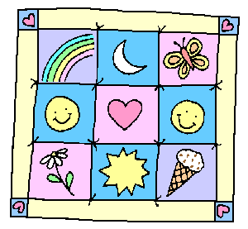
because there are rainbows, and butterflies,
and flowers, and chocolate chip ice cream cones,
and friends like you and me...

 | ...so take good care of yourself.  (eat healthy food, sleep well, laugh a lot,  and don't forget to get a mammogram!) | 
Take good care!

